INFO 1

From: Prof. Dr. Stanislaw Sterkowicz
Head of the Combat Sports Department of the Academy of Physical Education in Kraków - Poland

Dear Sirs,

At present there is an urgent need to coordinate research on special motor efficiency in judo in order to develop standards of evaluation that every coach will be able to benefit from.
Studies on the Special Judo Fitness Test have been conducted for several years (SJFT), which were presented during the previous scientific conference organized by Dr. D. Matsumoto and prof. Michel Brousse under the aegis of the International Judo Federation. The reliability of the SJFT is adequate enough to diagnose the level of contestants' preparation to enter for judo tournaments. Having conducted this test, which is of an intermittent nature and it simulates fragments of the fight, one can determine both the level of special motor efficiency, and indirectly evaluate the actual aerobic and anaerobic capacity of contestants. Its accuracy is attested by a high correlation between the SJFT and the level of anaerobic capacity (measured by Wingate-test) and aerobic power (VO2max in ml/kg/min) as well as by the ranking of contestants.
I have heard that some research centres and judo coaches outside my country have already introduced the SJFT advantageously to monitor their training sessions. Such tests were undertaken in Brazil, Georgia, New Zealand, Spain, and the United Kingdom.
I will be very grateful if the persons in charge of those tests send the result they collected with National Teams for our joint study.
If you are interested in conducting the test, please let me know this within 10 days. Then I shall send precise instructions to all who wish to join this project.
I would like to work out the results of our planned study statistically with Dr. Emerson Franchini from Brazil, to discuss them to introduce the SJFT standards of evaluation, and finally to make them available to you for practical purposes.
Yours faithfully,
Stanislaw Sterkowicz

INFO 2
SPECIAL JUDO FITNESS TEST
The test proposed by S. STERKOWICZ - this test follows the following protocol:

About the warm up - run about 5 min (moderate intensity), then perform some throws in a slow velocity just to adapt to the distance and to the uke.

Two judokas (uke) of similar stature and body mass of the performer (same category) are positioned at 6m of distance one of the other, while the performer of the test (tori) is to three meters of distance of the judokas that will be throw. The test is divided in three periods of 15s (A), 30s (B) and 30s (C) with intervals of 10s. During each one of the periods the performer throw the partners using the ippon-seoi-nage technique as much as possible. Immediately after, and 1 minute after the end of the test the athlete's heart rate is verified. The total of throws accomplished by period is added and an index is calculated according to the equation 1:
Index = final HR (bpm) + HR 1min after the end of the test (bpm)/ total number of throws (Equation 1)

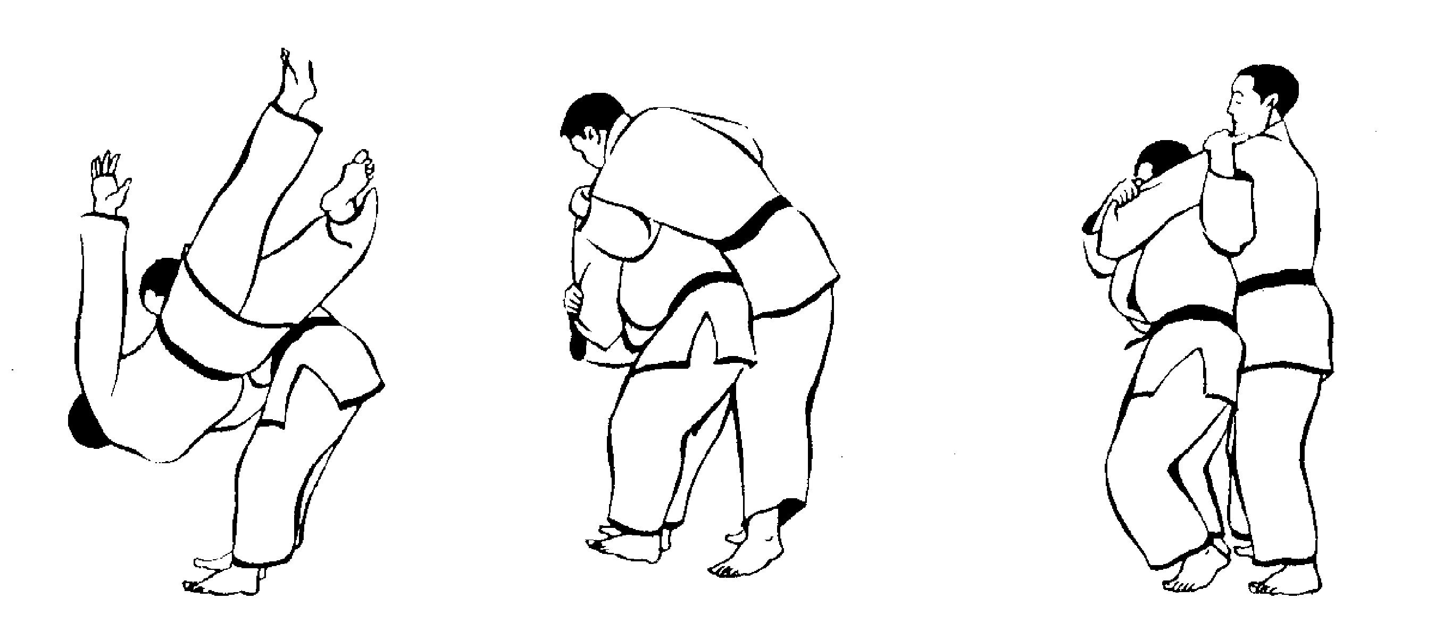
Contour of the ippon-seoi-nage technique (according to IWAI et al. 1977)
Outline of the test:
3m 3m
UkeA ________________ Tori _______________ Uke B
6m
Therefore as smaller the value of the index better the performance in the test. The heart rate can be obtained through the use of the POLAR monitor NV or similar device registering HR (beat per minute).

Department of Combat Sports
Cracow Academy of Physical Education - Poland

Special Judo Fitness Test Protocol:

Number of throws in Series A (15 s) ...............................
Number of throws in Series B (30 s) ...............................
Number of throws in Series C (30 s) ...............................
Heart rate immediately after all throws ..............................
Heart rate after 1 min ...................................
$S$------------------------------------------------------------
Please evaluate the effort in SJFT in comparison with judo fight (encirle similarity):
1 Very low
2 Low
3 Moderate
4 High
5 Very height

Name of competitor ................................
.............................................................................
Date of birth ..................................................
Body weight ....................................................kg
Weight category during competition ………..kg
Body height................................................cm.
Experience in judo (years) ....................................
Degree of advancement (Kyu, Dan) ........................................
Tokui waza ..........................................
..........................................................................

We would like emphasize that is a call for the National Team results.
Please keep touch with me in the subject.

Thank you

Stanislaw Sterkowicz wtsterko@cyf-kr.edu.pl

